HTML AND CSS ASSIGNMENT

-K.LIKHITHA DEVI

2K23CSUN01215

Question:1

The CSS Box Model is a fundamental concept in web design and development that defines how elements on a webpage are rendered in terms of their size and spacing. It describes the content area, padding, border, and **margin** of an element, all of which affect the layout and spacing of elements on a webpage.

The CSS Box Model consists of the following components

Padding: Padding is the space between the content and the element's border. It creates an internal spacing within the element.

Border: The border surrounds the padding and content, defining the visible boundary of the element. You can specify the border's width, style, and color.

Margin: Margin is the space outside the element's border. It defines the spacing between the element and its neighboring elements.

EXERCISE :

CODE

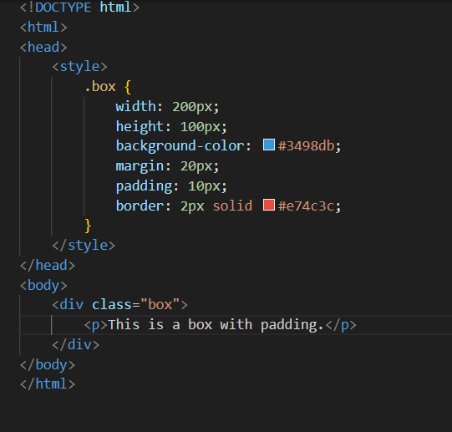

OUTPUT

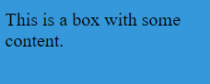

Question:2

. CSS specificity is a fundamental concept in Cascading Style Sheets (CSS) that determines which styles are applied to elements when multiple conflicting CSS rules are defined. It's a way to resolve the specificity of a rule, which helps the browser decide which style declarations should take precedence.

Specificity is determined by the combination of selectors in a CSS rule. It is typically represented as a four-part value, with each part contributing to the specificity in the following order:

Inline Styles: An inline style defined directly on an HTML element using the **style** attribute has the highest specificity. It's denoted as "1000."

ID Selectors: Selectors that target elements by their **id** attribute have the second-highest specificity. They are denoted as "100."

Class, Attribute, and Pseudo-class Selectors: These selectors target elements by their classes, attributes, or pseudo-classes (e.g., .class, [attribute], :hover). They have a specificity value of "10."

Element and Pseudo-element Selectors: These selectors target elements by their tag name or pseudo-elements (e.g., p, ::before). They have the lowest specificity and are denoted as "1."

EXERCISE :

CODE

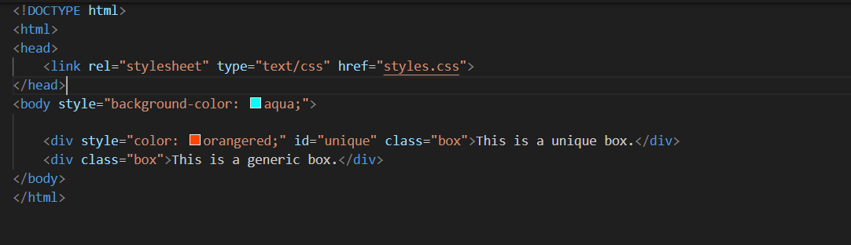

OUTPUT

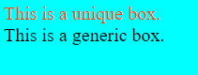

Question:3

CSS Flexbox and CSS Grid are layout models in CSS used to create flexible and responsive webpage layouts. Each layout model is designed for different use cases, and understanding when to use each one is crucial for effective web design.

**CSS Flexbox**:

Flexbox (Flexible Box Layout) is designed for arranging and aligning elements in a single dimension (either horizontally or vertically).

It's best for creating complex, dynamic layouts within a container where the size of the items is unknown or variable, and you want them to automatically adjust to the available space.

Flexbox is great for creating navigation menus, sidebars, and aligning items within a single row or column.

EXERCISE :

CODE

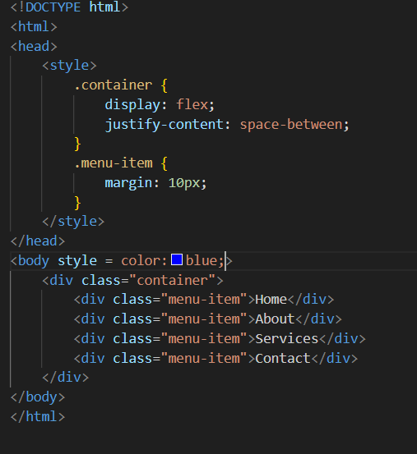

OUTPUT: 

Question:4

There are several values for this property, but I'll focus on **position: relative**, **position: absolute**, and **position: fixed**, explaining the differences and use cases for each:

position: relative:

Elements with position: relative are positioned relative to their normal position in the document flow.

When you use top, right, bottom, or left properties with position: relative, the element is shifted from its original position without affecting the layout of surrounding elements. This is often used for fine-tuning the position of elements.

position: absolute:

Elements with position: absolute are removed from the normal document flow and positioned relative to the nearest ancestor with a positioned property (relative, absolute, or fixed). If no positioned ancestor exists, it's positioned relative to the initial containing block (usually the viewport).

You can use top, right, bottom, and left properties to precisely place elements anywhere on the page. This is useful for creating overlays, tooltips, and complex layout components.

position: fixed:

Elements with position: fixed are removed from the document flow and positioned relative to the viewport, which means they stay in the same position even when the user scrolls the page.

top, right, bottom, and left properties are used to position fixed elements. This is commonly used for headers, footers, or naviga

EXERCISE:

CODE

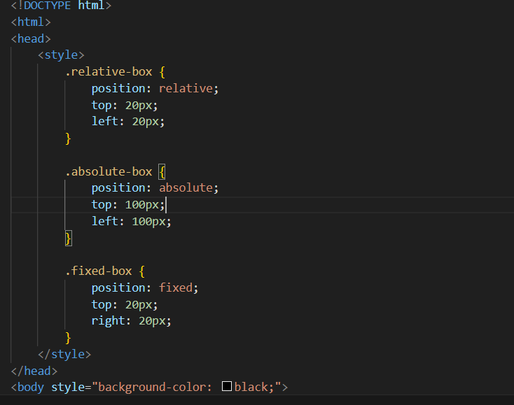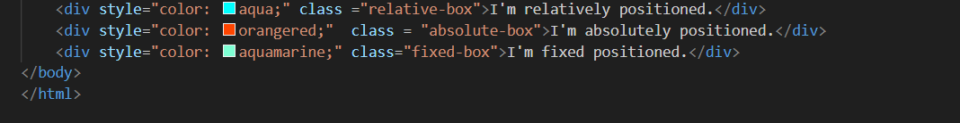

OUTPUT:

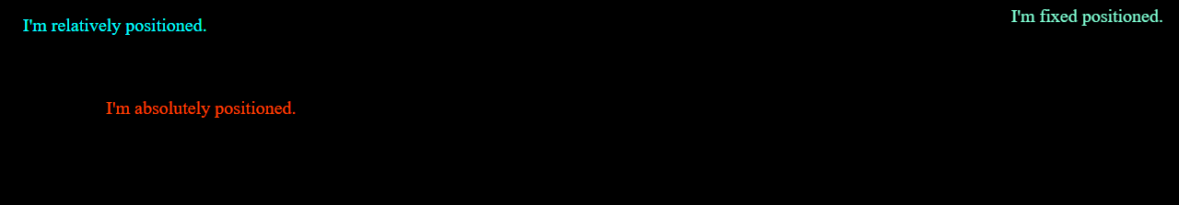

Question:5

Before:

The before pseudo-element is used to insert content before the content of the selected element.

It is often used to add decorative elements or create icons, bullets, or labels before a content element.

After:

The after pseudo-element is used to insert content after the content of the selected element.

It's commonly used to add decorative elements, create tooltips, or indicate external links with icons or text.

EXERCISE:

CODE

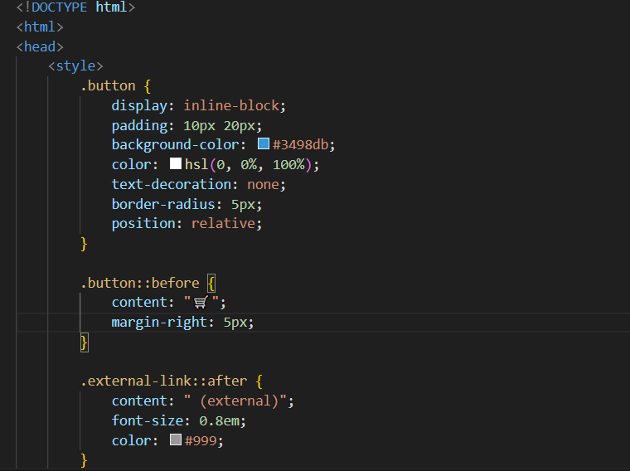

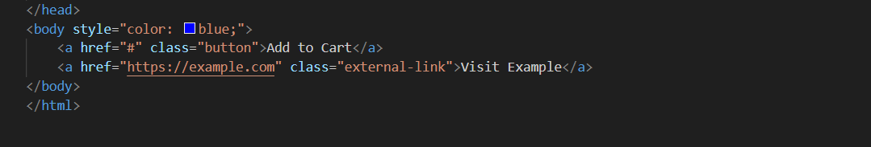

OUTPUT:

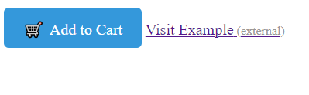

Question:6

**Responsive web design** is an approach to designing webpages that aims to provide an optimal viewing and interaction experience across a wide range of devices and screen sizes. The goal is to ensure that the webpage adapts to the user's device, whether it's a desktop computer, tablet, or mobile phone. Responsive web design typically involves flexible layouts, fluid images, and media queries to achieve this adaptability.

**Media queries** are CSS rules that allow you to apply different styles to a webpage based on the characteristics of the device viewing it. They are commonly used to change the layout, fonts, and other design elements in response to factors like screen size, device orientation, or print vs. screen.

EXERCISE:

CODE

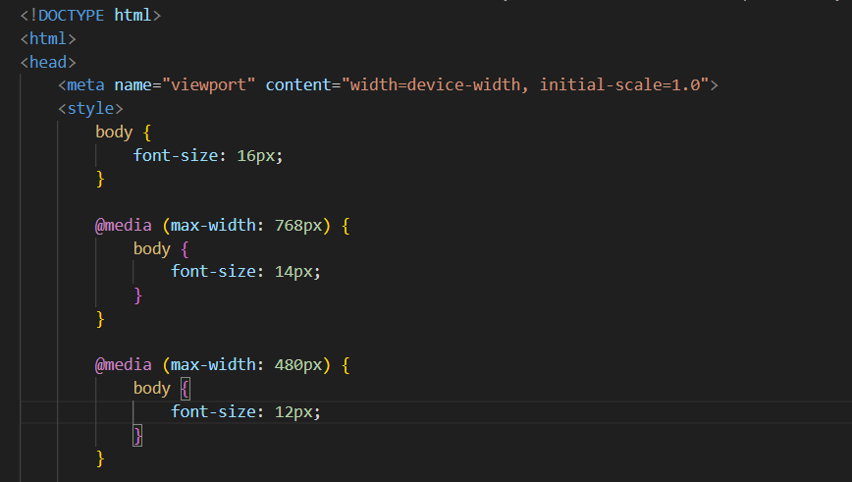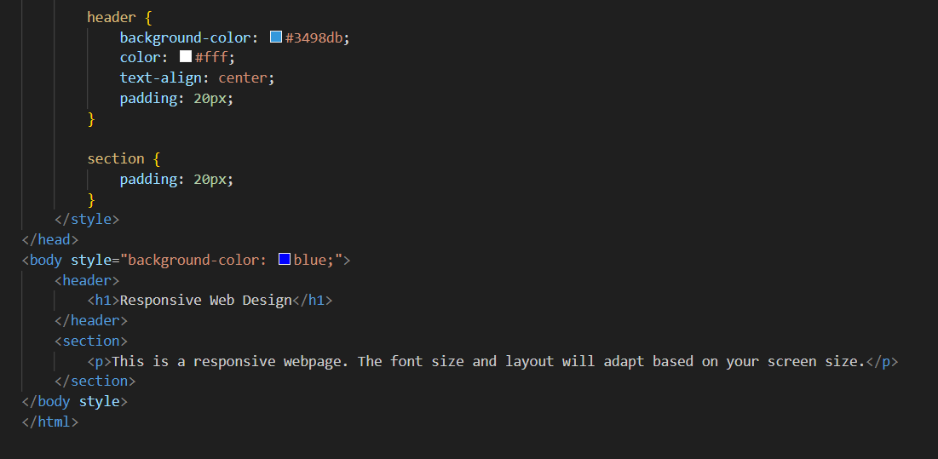

OUTPUT:

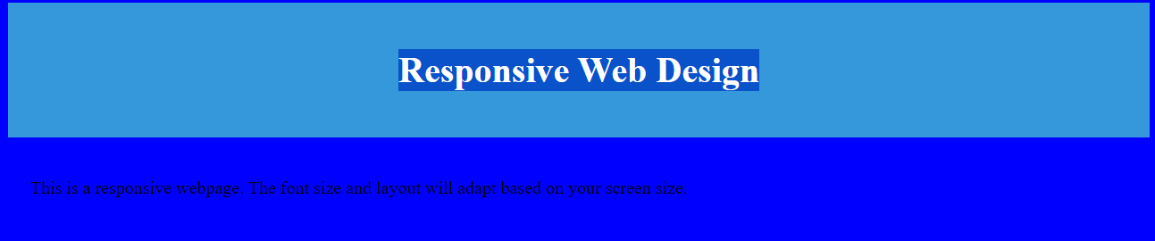

Question:7

Accessibility in web development is crucial for ensuring that websites and web applications are usable and accessible to all users, including those with disabilities. It involves designing and developing digital content in a way that accommodates various impairments and disabilities, such as visual, auditory, motor, or cognitive impairments. By making web content accessible, developers can ensure that everyone, regardless of their abilities, can perceive, understand, navigate, and interact with the content effectively.

 ARIA (Accessible Rich Internet Applications) roles and attributes are a set of attributes defined by the W3C that can be added to HTML elements to improve the accessibility of web content for users with disabilities. ARIA roles and attributes help assistive technologies, such as screen readers, interpret and convey the functionality and information of web elements to users, enabling a more accessible and inclusive user experience.

EXERCISE:

CODE:

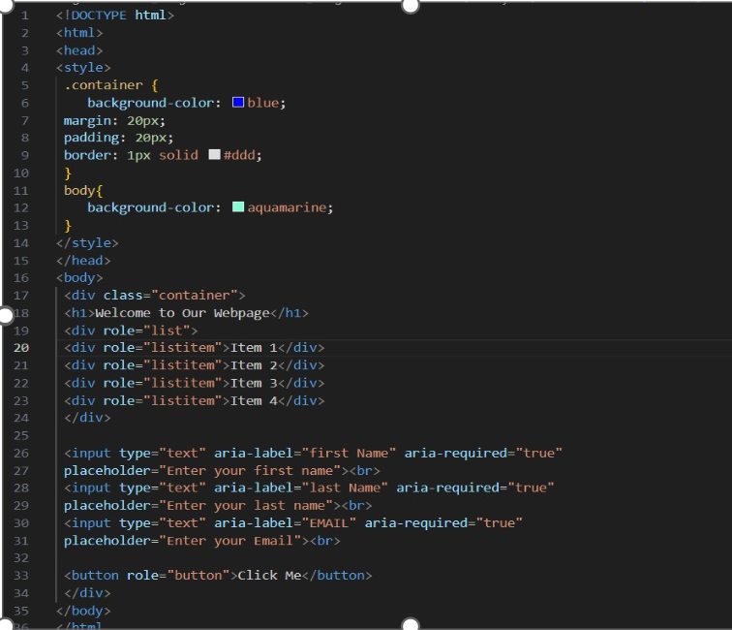

OUTPUT:

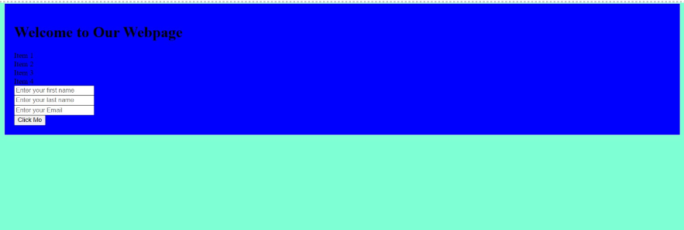

Question: 8

The declaration in HTML (Hypertext Markup Language) is used to specify the version of HTML or XHTML that a web document is using. It serves as an instruction to web browsers and other software about how to interpret the markup of the document. The purpose of the declaration is to ensure that the web document is displayed correctly and consistently across different web browsers.

 Different web browsers have their own rendering engines, which interpret HTML and CSS to display web content. The presence of a correct and valid declaration ensures that the browser renders the webpage in standards-compliant mode, following the specified rules and standards for the declared version of HTML or XHTML. This helps maintain consistency and predictability in how the webpage is displayed across different browsers and devices

A.

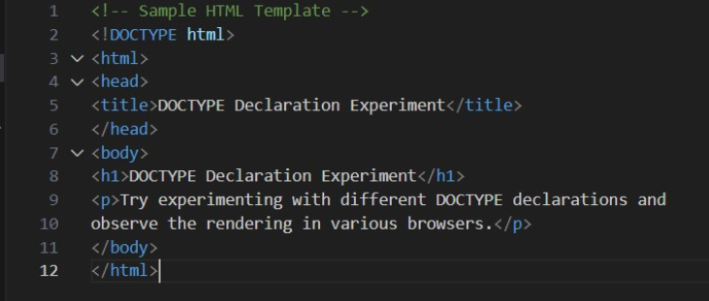

B.

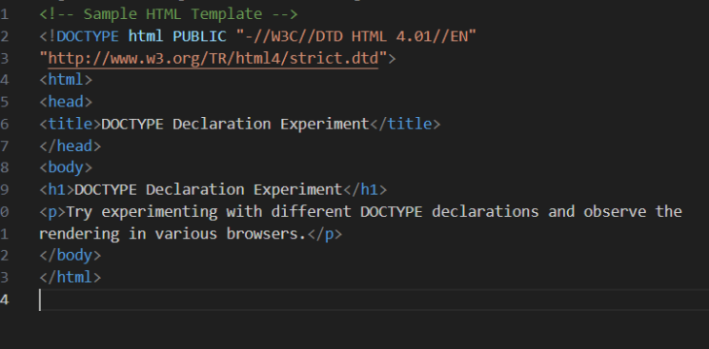

C.

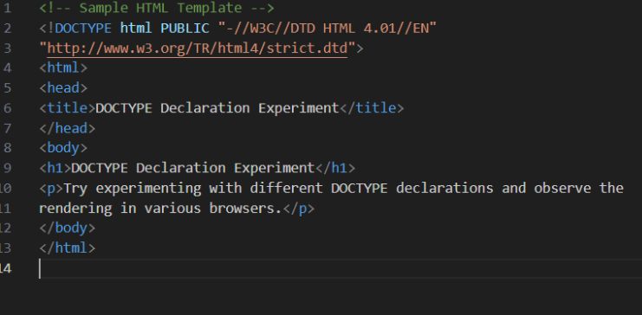

D.

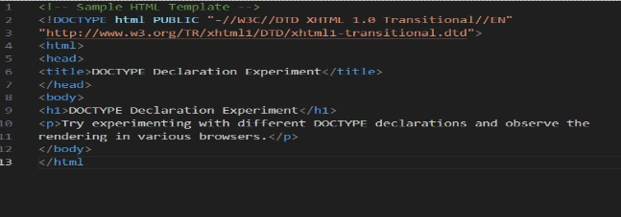

E

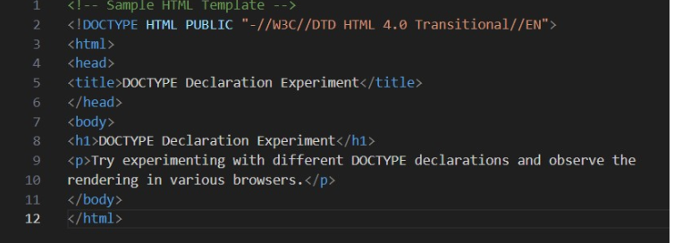

OUTPUT:

